Docker Installation

1. To install docker, follow the steps(commands).

Update package information, ensure that APT works with the https method, and that CA certificates are installed.

|  |
| --- |
| **apt-get update** |

|  |
| --- |
| **apt-get install apt-transport-https ca-certificates** |

1. Add the new GPG key.

|  |
| --- |
| **apt-key adv --keyserver hkp://p80.pool.sks-keyservers.net:80 --recv-keys 58118E89F3A912897C070ADBF76221572C52609D** |

|  |
| --- |
| **echo "<REPO>" | sudo tee /etc/apt/sources.list.d/docker.list**  **(replace REPO with “deb https://apt.dockerproject.org/repo ubuntu-trusty main”)** |

1. Update the APT package index and verify the output.

|  |
| --- |
| **apt-get update** |

|  |
| --- |
| **apt-cache policy docker-engine** |

Will get a similar output.

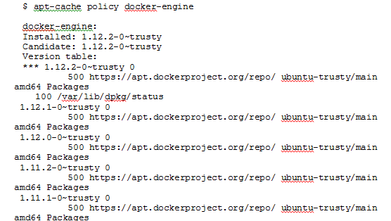

1. Update and install Docker

|  |
| --- |
| **apt-get update** |

|  |
| --- |
| **apt-get install docker-engine** |

1. Start the Docker Daemon.

|  |
| --- |
| **service docker start** |

1. Verify Docker Installation.

|  |
| --- |
| **docker run hello-world** |

**Installing Docker Compose**

1. Install python-pip.

|  |
| --- |
| **apt-get -y install python-pip** |

1. Install docker-compose .

|  |
| --- |
| **pip install docker-compose** |

1. Create a docker-compose.yml file using any editor.

For example:

|  |
| --- |
| docker-compose.yml |
| eureka-server:  image: eureka-server  ports:  - "8761:8761"  sampleservice:  image: db-operation-service  hostname: sample-service  links:  - eureka-server  environment:  EUREKA_HOST: eureka-server  EUREKA_PORT: 8761  SERVER_PORT: 9099  SPRING_PROFILES_ACTIVE: docker  ports:  - "9099:9099"  db:  image: db  hostname: db  links:  - eureka-server  environment:  EUREKA_HOST: eureka-server  EUREKA_PORT: 8761  SERVER_PORT: 8089  SPRING_PROFILES_ACTIVE: docker  ports:  - "8089:8089" |

1. Start the docker-compose by

|  |
| --- |
| docker-compose up -d |

It will start all the docker images configured in the docker-compose.yml file.